1. Configure MS Word Application: Go To File->Options->Trust Center->Trust Center Settings and allow Macros and VBA

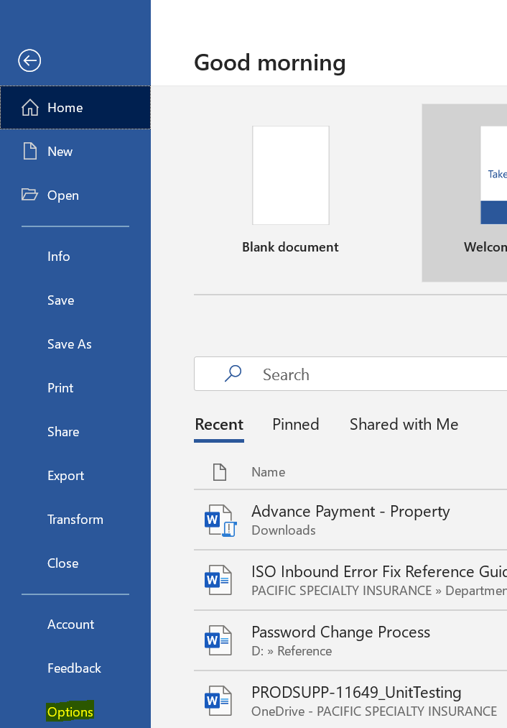

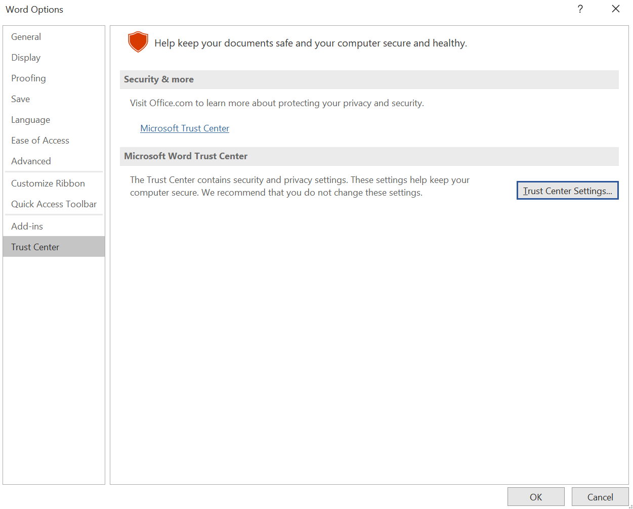

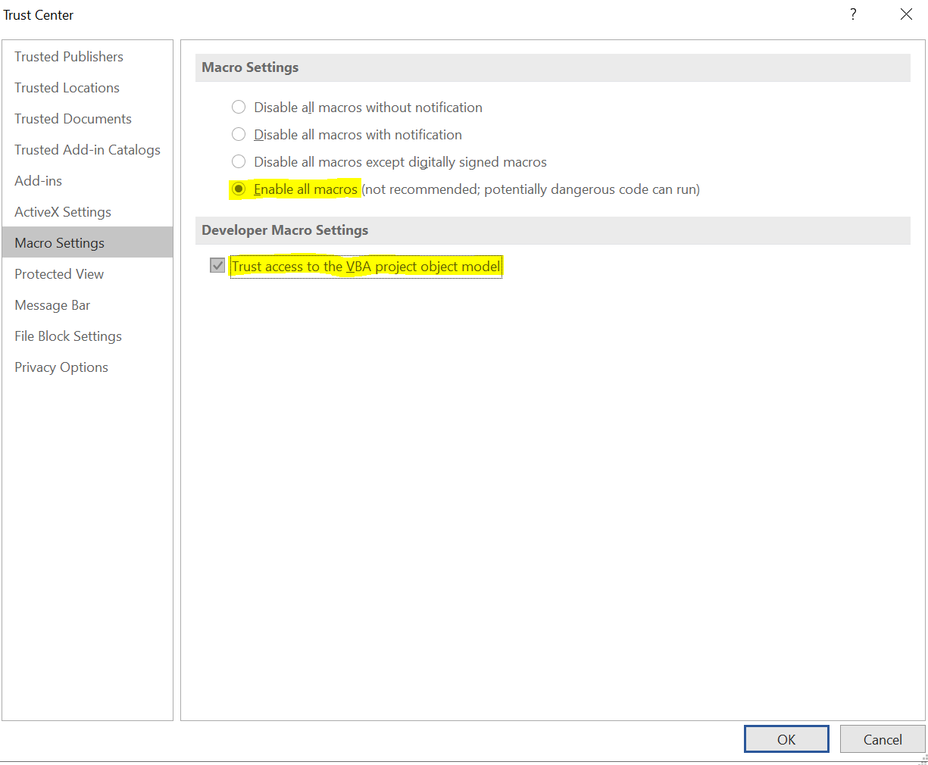

1. Configure browser(Chrome used here) – enable popup

1. Open Link -

<https://uwd07.duckcreekondemand.com/Claims/Desktop/HomePage/Default.aspx?src=%2fClaims%2fDesktop%2fHomePage%2fHomePage.aspx&StaticPulseMode=true&IframeMode=true&Userid=EVERYONE>

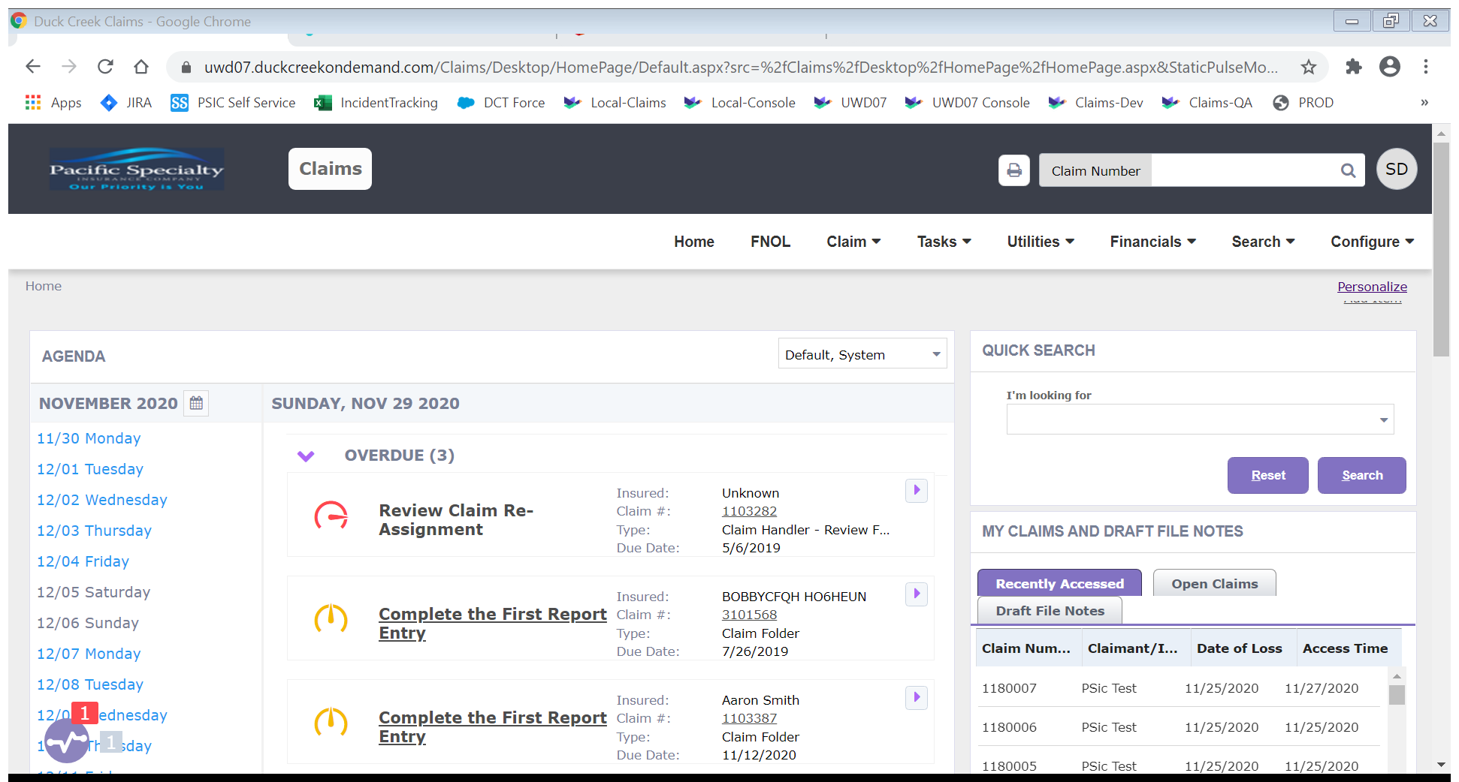

On the top right search box enter the Claim Number that you want to generate document and click the search Icon

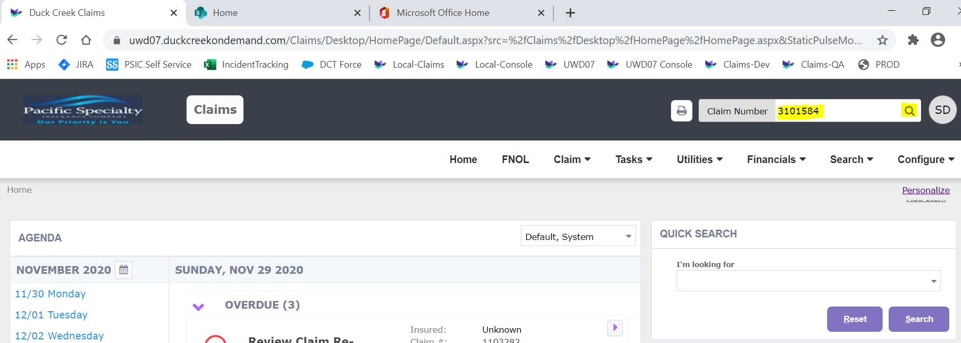

The Claim will be loaded

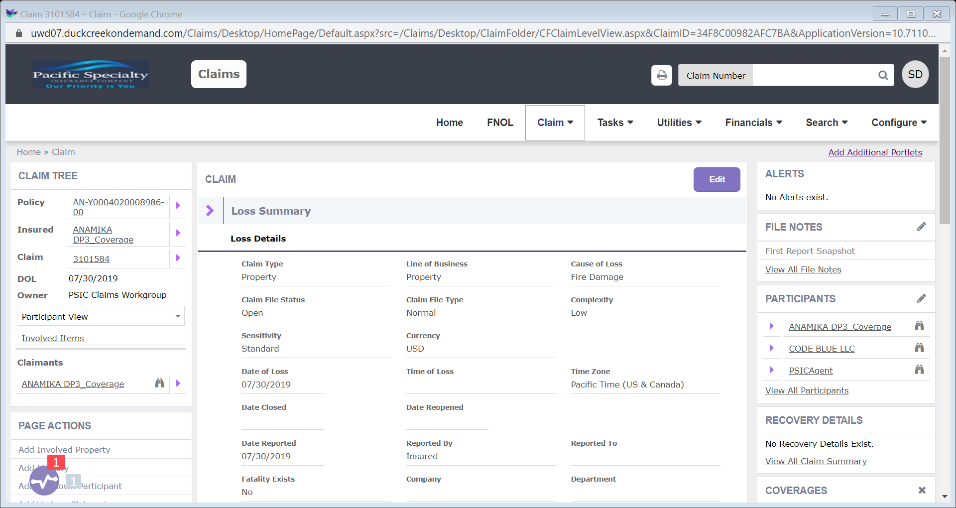

At the Bottom Left Corner “I NEED TO” section click the link “Create a Letter”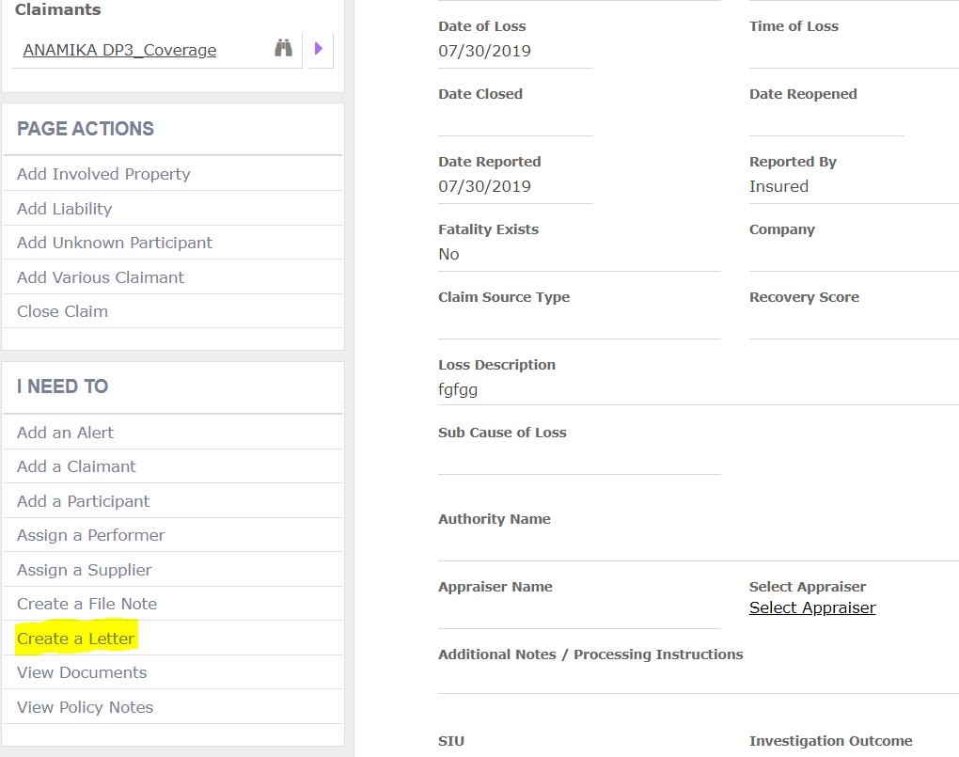

On the opened screen expand the Additional Criteria arrow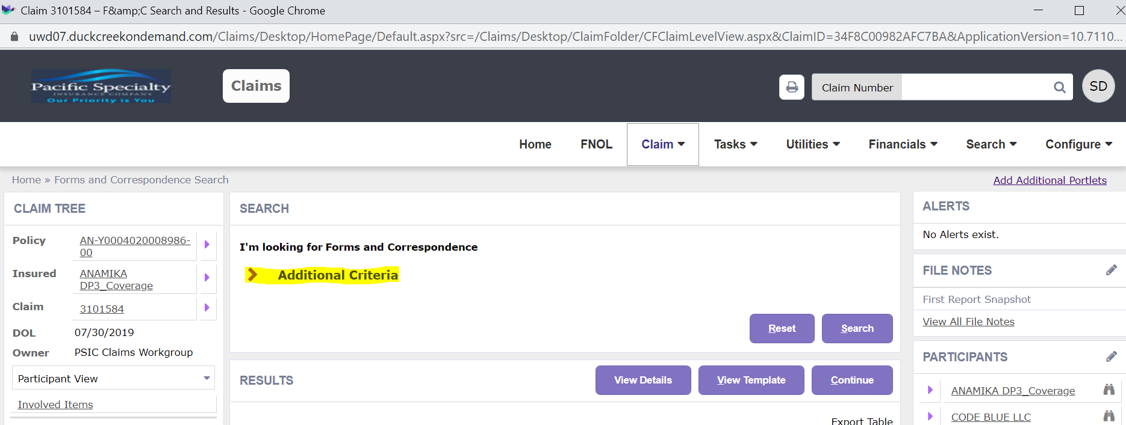

Under Additional Criteria section enter Template name “Advance” (you may enter any other template if aware of the name)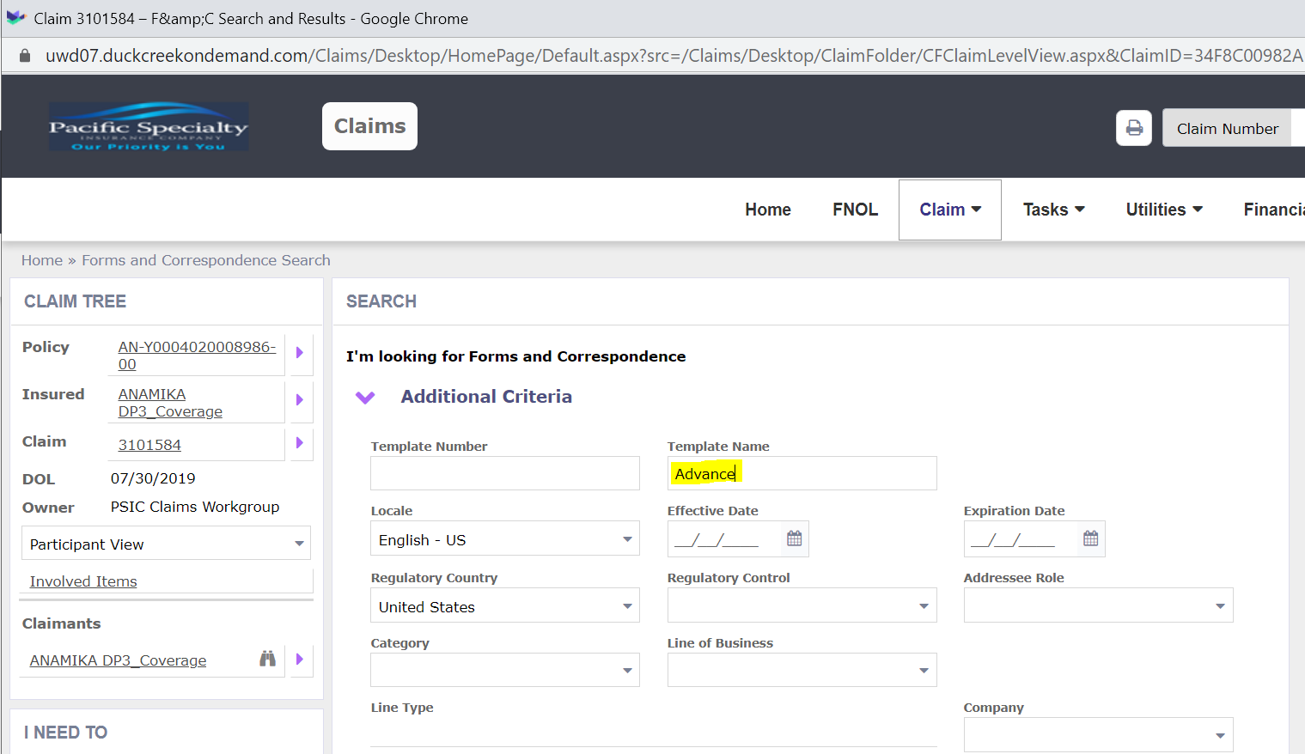

Click search button, system will show below template which matches your search word

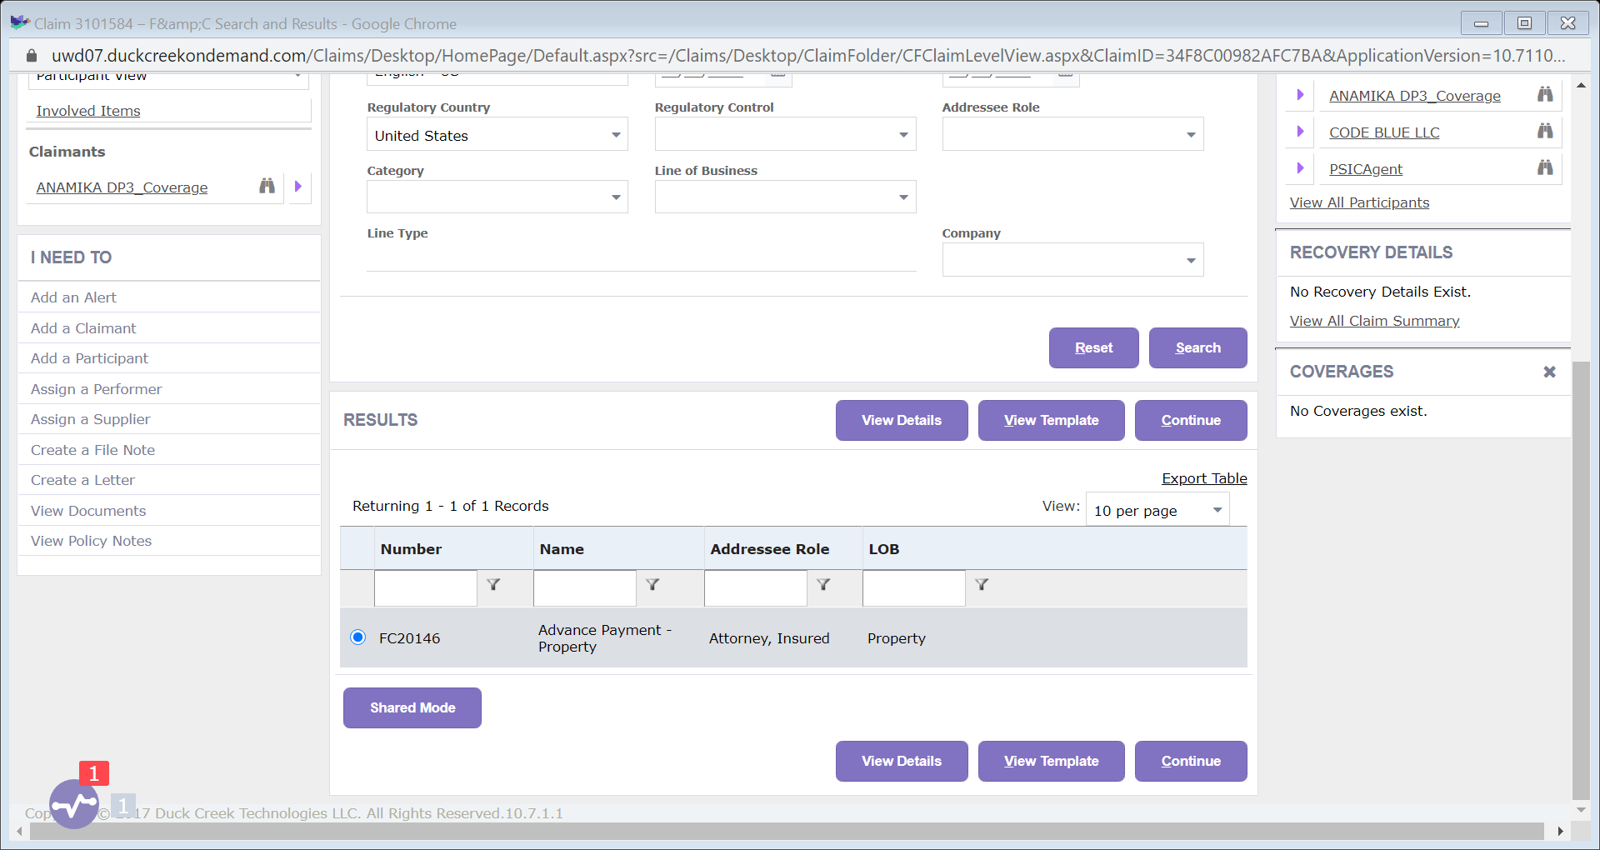

Click continue, it will show dynamic form data. You may manually enter/change if needed

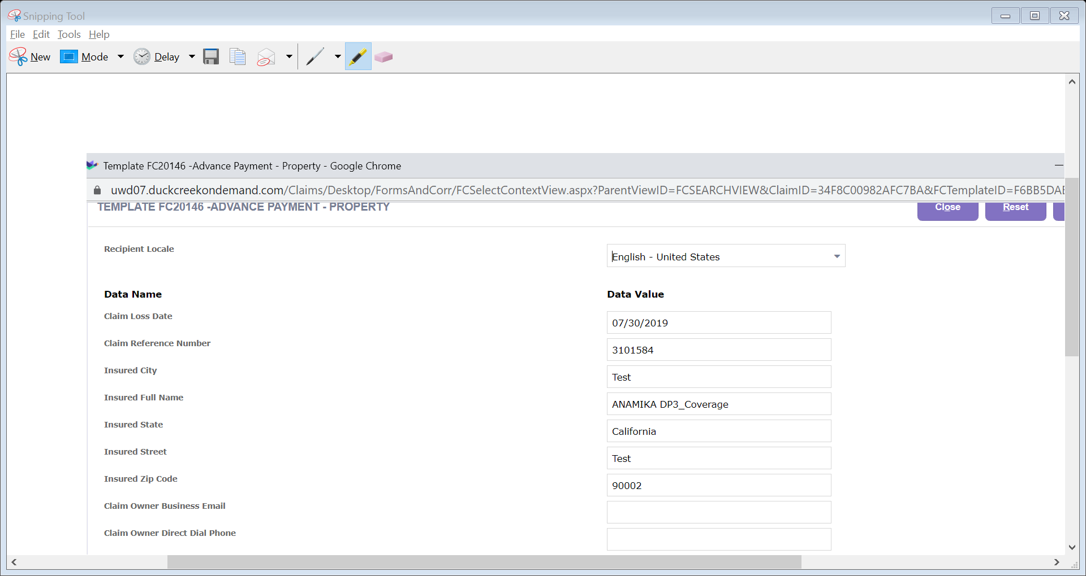

Click Continue

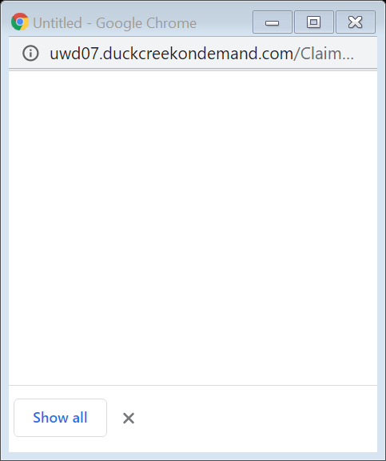

The letter will be downloaded in a pop-up window – maximize the window to see

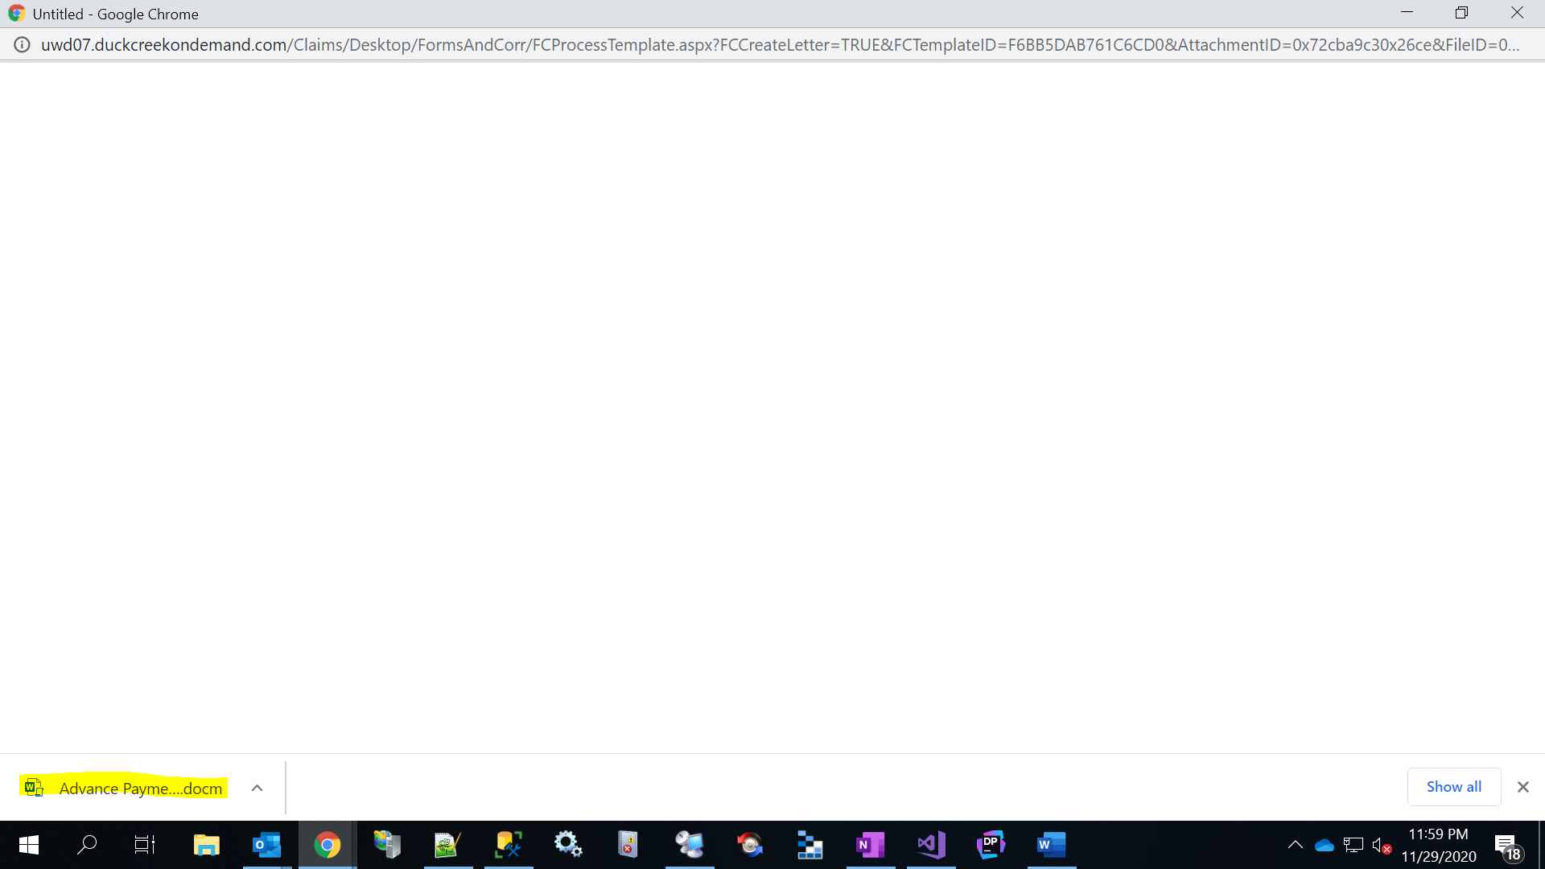

Open the downloaded letter

Open, then save as your desired format if you need PDF or DOCX

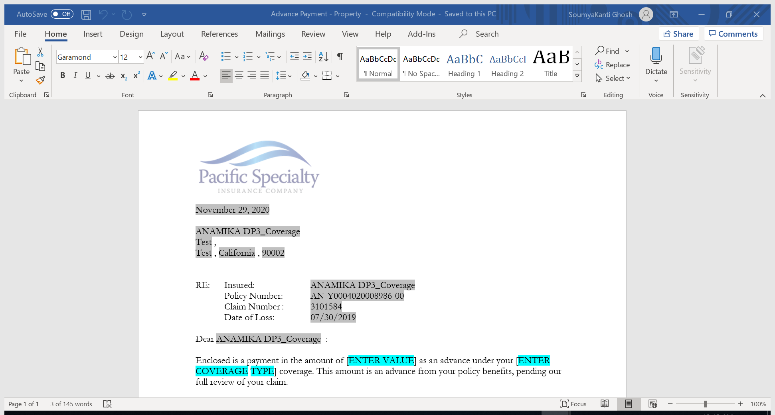

While using the link if at any point of time screen shows error that The URL is invalid or on button click it does not work, the screen just gets refreshed without the desired result then please close all your browser window and open the link again and try to do the steps. This is a known problem of Dev and QA regions.